**DAILY ONLINE ACTIVITIES SUMMARY**

|  |  |  |  |  |  |  |  |  |
| --- | --- | --- | --- | --- | --- | --- | --- | --- |
| **Date:** | **25/06/2020** | | | | | **Name:** | **Shailashree** | |
| **Sem & Sec** | **IV sem & B section** | | | | | **USN:** | **4AL18CS077** | |
| **Online Test Summary** | | | | | | | | |
| **Subject** | | **-** | | | | | | |
| **Max. Marks** | | **30** | | **Score** | | | **-** | |
| **Certification Course Summary** | | | | | | | | |
| **Course** | **Blockchain Basics** | | | | | | | |
| **Certificate Provider** | | | **Great learning academy** | | **Duration** | | | **2.5hours** |
| **Coding Challenges** | | | | | | | | |
| **Problem Statement1:** Write a C Program to reverse the rows in a 2d Array. | | | | | | | | |
| **Status: Executed** | | | | | | | | |
| **Uploaded the report in GitHub** | | | | | **YES** | | | |
| **If yes Repository name** | | | | | **Online-coding** | | | |
| **Uploaded the report in slack** | | | | | **YES** | | | |

Online Test Summary: No internals conducted today.

Online Certification Course Summary: In today’s session I have learnt about Consensus mechanism how it works in blockchain what exactly it is and what is the benefit of that mechanism.

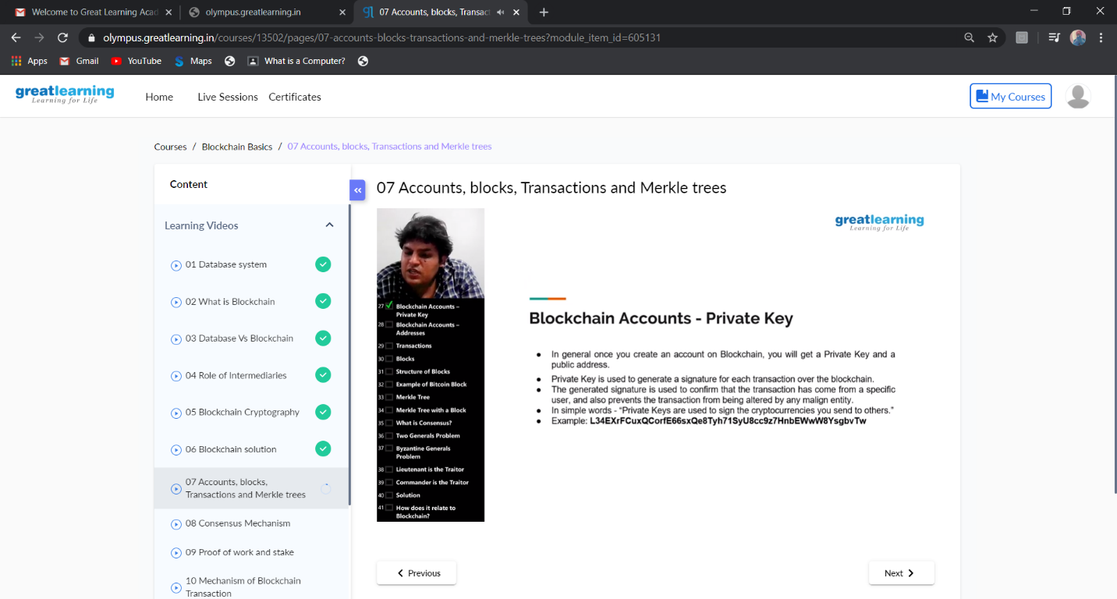

This is the snap shot of today’s session.

Online Coding Summary: **Today I had received one program from prof. Shilpa CSE Dept. The program is mentioned above in the coding challenges(pg.01). I have also uploaded it to my GitHub repository.**

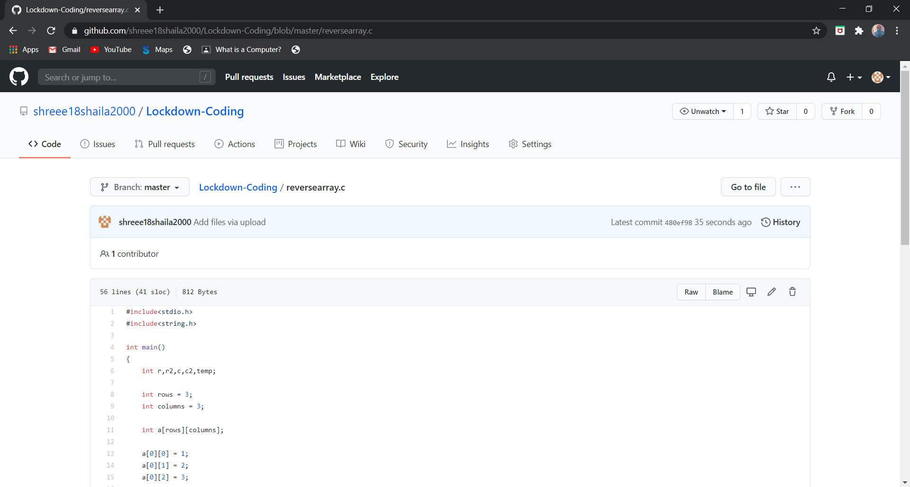

This is the snap shot of my repository were I have uploaded the code. File name is reversearray.c

Online Training: Today I had attended the online training organized by CSE Department AIET. The training was on Why C++, Introduction to OOP, Features done by Prof. Shruthi Shetty J. CSE Dept. After the session the quiz was conducted.

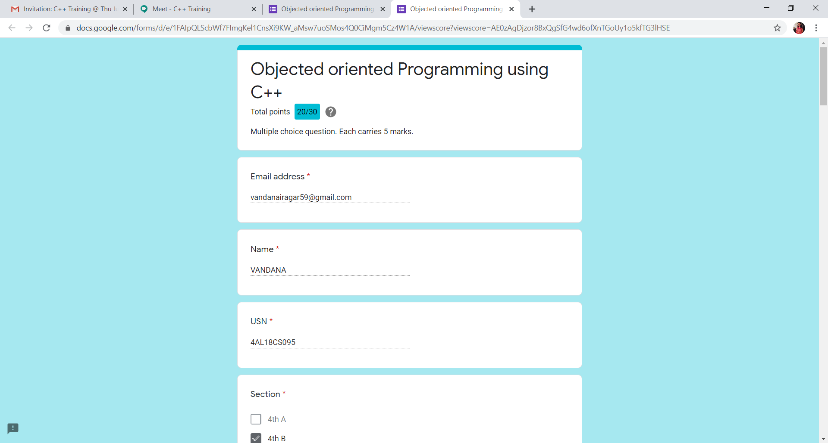

**This is the snap shot of the quiz attempted and the marks obtained.**